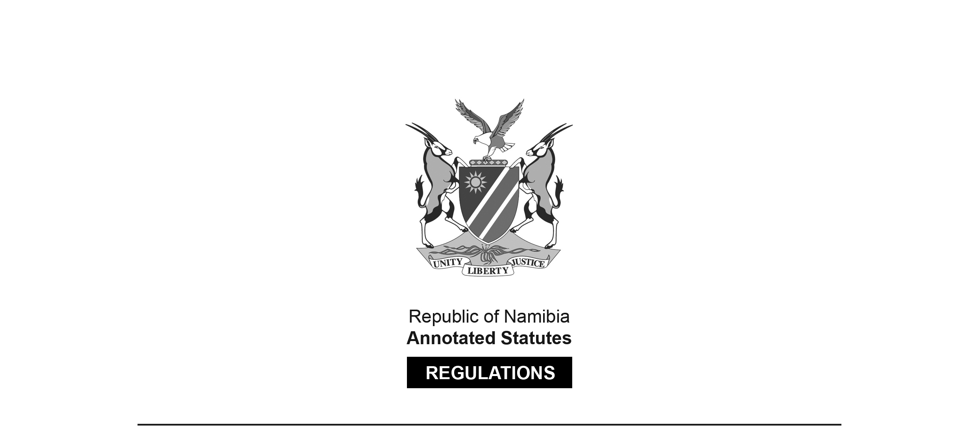
REGULATIONS MADE IN TERMS OF

Road Traffic and Transport Act 22 of 1999
section 72(1)(a) and (b)

Regulations to give effect to Cargo Levy Provisions of
Cross-Border Road Transport Agreement known as
the Agreement among the Governments of the Democratic Republic of Congo, the Republic of Namibia and the Republic of Zambia on the Establishment of the Walvis Bay-Ndola-Lumbumbashe Development Corridor
Government Notice 117 of 2026
(GG 8879)

ARRANGEMENT OF REGULATIONS

1. Definitions
2. Cargo levy
3. Liability for payment of cargo levy
4. Collection and administration of cargo levy
5. Time and manner of payment of cargo levy
6. Inspection

Definitions

1. In these regulations a word or an expression to which a meaning has been assigned in the Act has that meaning, and unless the context otherwise indicates -

“agreement” means the cross-border road transport agreement known as the Agreement among the governments of the Democratic Republic of Congo, the Republic of Namibia and the Republic of Zambia on the establishment of the Walvis Bay-Ndola-Lubumbashe Development Corridor signed on 5 March 2010 and ratified by the National Assembly on 7 April 2021;

“Banking Institutions Act” means the Banking Institutions Act, 2023 (Act No. 13 of 2023);

“border post” means the Katima Mulilo border post or the Ngoma border post;

“cargo” means goods defined in section 1 of the agreement;

“cargo levy” means the levy on the cargo referred to in regulation 2;

“Namibia Revenue Agency” means the Revenue Agency established by section 2 of the Namibia Revenue Agency Act, 2017 (Act No. 12 of 2017);

“operator” means a person who uses a vehicle to transport cargo by road;

“Permanent Secretariat” means the organ of the administration of the Walvis Bay–Ndola– Lubumbashe Corridor Management Committee referred to in paragraph d of Article 7 of the agreement;

“Road Fund Administration” means the Road Fund Administration established by section 2 of the Road Fund Administration Act, 1992 (Act No. 18 of 1992);

“the Act” means the Road Traffic and Transport Act, 1999 (Act No. 22 of 1999); and

“vehicle” means a vehicle as defined in section 68 of the Act.

Cargo levy

2. A levy of 0.90 United States dollar is payable on each ton of cargo transported through a border post by means of a vehicle using the road.

Liability for payment of cargo levy

3. (1) An operator of a vehicle that transports cargo by road must pay a cargo levy -

(a) when the vehicle enters Namibia at the border post; or

(b) when the vehicle departs from Namibia at the border post.

(2) An operator may not enter Namibia or depart from Namibia at the border post unless the cargo levy is paid.

(3) A person who contravenes or fails to comply with subregulation (2) commits an offence and is on conviction liable to fine of N$8000 or imprisonment for two years, or both to such fine and imprisonment.

Collection and administration of cargo levy

4. (1) The Road Fund Administration must collect and administer the cargo levy on behalf of the Permanent Secretariat.

(2) The Road Fund Administration -

(a) must open a bank account with a banking institution registered in terms of the Banking Institutions Act; and

(b) must deposit the cargo levy payable in terms of these regulations into the bank account referred to in paragraph (a).

(3) The Road Fund Administration is entitled to retain 15 percent from each payment of a cargo levy to defray its administrative expenditure.

(4) The Road Fund Administration must, before the 20th day of each month, deposit the money received during the preceding period as the cargo levy into the bank account of the Permanent Secretariat.

(5) The Road Fund Administration must deduct the 15 percent referred to in subregulation (3) before depositing the money received as cargo levy into the bank account of the Permanent Secretariat.

(6) The Road Fund Administration must provide the Permanent Secretariat with -

(a) bank statements relating to each payment of a cargo levy; and

(b) a summary of transactions relating to each payment of a cargo levy.

(7) The Permanent Secretariat must open a bank account with a banking institution registered in terms of the Banking Institutions Act to receive the money payable to it by the Road Fund Administration.

(8) The Permanent Secretariat must use the money deposited by the Road Fund Administration to defray its operational and administrative expenditure.

(9) The Permanent Secretariat must appoint an accounting officer to -

(a) keep accounting records as are necessary to reflect fairly the state of affairs and business of the Permanent Secretariat; and

(b) explain the transactions and financial conditions of the Permanent Secretariat.

Time and manner of payment of cargo levy

5. (1) When an operator reaches the border post the operator must submit a declaration containing the weight of the cargo to a staff member of the Namibia Revenue Agency authorised by the Namibia Revenue Agency for that purpose.

(2) The staff member of the Namibia Revenue Agency authorised by the Namibia Revenue Agency for that purpose must assess and verify the declaration referred to in subregulation (1) and issue a verification document to the operator.

(3) The operator must on receiving the verification document referred to in subregulation (2) -

(a) submit the verification document and a cross-border permit to a staff member of the Road Fund Administration authorised by the Road Fund Administration for that purpose at the border post; and

(b) pay the cargo levy to a staff member of the Road Fund Administration authorised by the Road Fund Administration for that purpose.

(4) The staff member of the Road Fund Administration authorised by the Road Fund Administration for that purpose must on receiving the payment for the cargo levy in terms of subregulation (3)(b) issue the operator with a proof of payment.

Inspection

6. (1) An operator who is issued a proof of payment in terms of regulation 5(4) must present the proof of payment for inspection on request by a staff member of the Road Fund Administration authorised by the Road Fund Administration for that purpose or a person authorised by the Minister in accordance with section 102(1) of the Act to carry out inspections.

(2) An operator must at all times while in Namibia keep the proof of payment issued in terms of regulation 5(4) in the vehicle concerned.

(3) A person who contravenes or fails to comply with subregulation (1) commits an offence and is on conviction liable to fine of N$8000 or imprisonment for two years, or both to such fine and imprisonment.

[The article “a” appears to have been omitted before the phrase “fine of N$8000”. The words “both” and “to” appear to have been reversed in the phrase “both to such fine and imprisonment”, which is likely to have been intended to read “to both such fine and imprisonment”.]

